Introduction

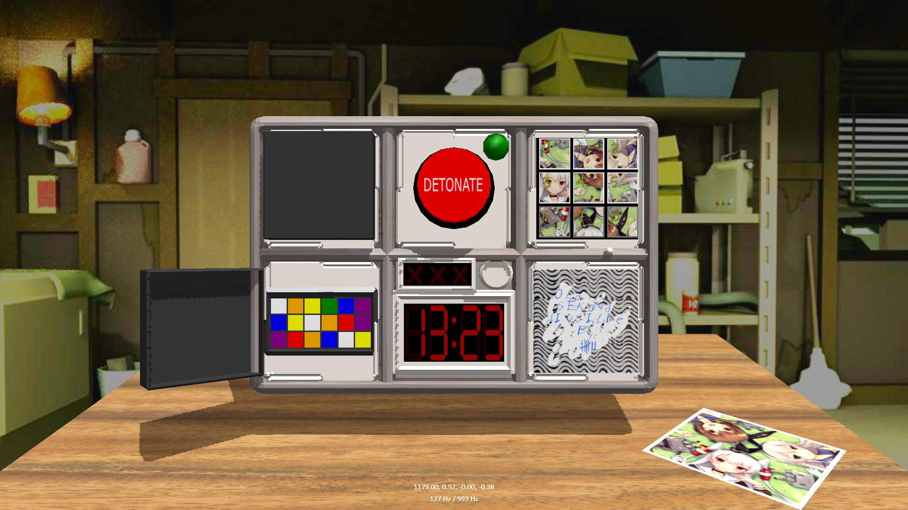The goal of this project is to recreate the well-known VR game « Keep Talking and Nobody Explodes », but with haptic puzzles. The original game was a huge inspiration to our project, however, we decided to add our own perks to it. As many people may know, « Keep Talking and Nobody Explodes » is a multi-player game where only one person can see the bomb. The other players have a set of rules for what to do for each puzzle depending on the state of the bomb. Players must communicate in order to clear the puzzles before the timer runs out. For our project, we decided it would be best to modify it to be a single player game. Much like an escape room, our version requires the player to complete a series of puzzles in order to figure out what sequence of the wires to cut to defuse the bomb before the timer runs out. Of course, haptics is incorporated into each of the puzzles, and players must use the Novinct Falcon to touch, feel, and interact with the bomb in order to solve the puzzles, and beat the timer.

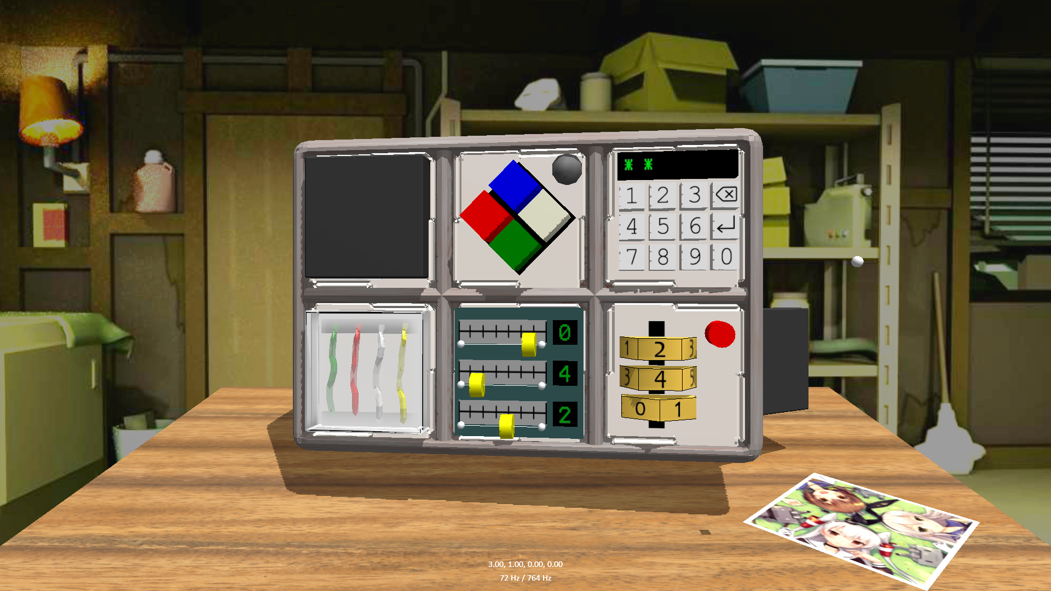

Methods

**Keep Touching and Nobody Explodes** **Teresa Van**

**& Adrian Bathan**

We used the same custom proxy algorithm for feeling objects and textures that was used in our third assignment. This proxy algorithm was used for interacting with all of our objects, some including friction and height maps, such as our scratch and win puzzle, braille puzzle, table, and bomb object. The limitations to this algorithm was that it was hard to combine other proxy algorithms that were better for certain interactions such as mass spring systems and magnetism.

To accomplish mass spring systems for our buttons, we had to retrieve the contact force from the proxy algorithm and perform velocity and force calculations independent of the proxy algorithm.

Using a similar method, we were able to achieve dynamic forces such as rotation on the dials/covers, as well as translation for the sliding picture puzzle.

Results

Our version of « Keep Talking and Nobody Explodes » felt very successful. Our game is visually very similar to the original game, which was what we were aiming for in terms of aesthetics. We were also able to come up with some interesting puzzles that involves haptics. The haptics for each puzzle also feels arguably very realistic ; dynamically modifying the friction and height maps of the scratch and win puzzle produced very convincing results as it felt like actually scratching the label off. Using a mass spring system for the buttons also produced pleasing results for pressing a button and feeling the ‘click’ and resistance as if from a real button. The integration of haptics into a highly interactive game like « Keep Talking and Nobody Explodes » created a more immersive experience for playing the game by allowing the combination of multiple sensory stimuli to further enhance the experience of the game.

